|  |  |
| --- | --- |
|  |  |
| ARTIFICIAL INTELLIGENCE **(CS-323)** | **CEP** |
|  |  |

**Project ID: 42**

**SMART CAREER GUIDANCE**

**(EXPERT SYSTEM)**

**Group members:**

Usman Yousuf CS-20099

Yasoob Raza CS-20109

Hassan Mehdi CS-20120

**Submitted to:**

Ms. Fauzia Yasir

Date: 19th January ,2023

**Introduction:**

The "Smart Career Guidance System" is an expert system designed to assist students in making informed decisions about their future careers. The system utilizes a combination of multiple choice questions and rule-based reasoning to evaluate the student's interests, skills, and aptitudes. The system then suggests the most appropriate fields of study and career paths that would best match the student's profile.

**Problem description:**

The problem that the "Smart Career Guidance System" aims to address is the difficulty that students face in choosing a career path that aligns with their interests, skills, and aspirations. Students often find it challenging to navigate the vast array of options available to them and to make an informed decision about their future careers. This can lead to confusion, frustration, and ultimately, poor career choices that do not align with their strengths and interests.

The problem is further compounded by the lack of accurate and up-to-date information about the different fields of study and career paths available to students. This makes it difficult for students to make informed decisions about their future careers, and it also makes it challenging for educators and career counselors to provide effective guidance to their students.

The "Smart Career Guidance System" aims to solve this problem by providing students with a user-friendly and easy-to-use tool that can help them to make informed decisions about their future careers. The system uses a combination of multiple choice questions and rule-based reasoning to evaluate the student's interests, skills, and aptitudes and to suggest the most appropriate fields of study and career paths that would best match the student's profile

**Project Features:**

The "Smart Career Guidance System" aims to solve this problem by providing students with a user-friendly and easy-to-use tool that can help them to make informed decisions about their future careers. The system uses a combination of multiple choice questions and rule-based reasoning to evaluate the student's interests, skills, and aptitudes and to suggest the most appropriate fields of study and career paths that would best match the student's profile

The "Smart Career Guidance System" project has several distinguishing features that set it apart from other career guidance systems:

Personalized evaluation: The system uses a combination of multiple choice questions and rule-based reasoning to evaluate the student's interests, skills, and aptitudes and to suggest the most appropriate fields of study and career paths that would best match the student's profile.

Up-to-date information: The system is based on the latest research and data, and it is regularly updated to reflect the latest job market trends. This ensures that the information provided to the students is accurate and relevant.

Detailed information: The system provides detailed information about the different fields of study and career paths, including their job prospects, earning potential, and the required qualifications.

Cost-effective: It is a cost-effective solution for career guidance, as it can be used by many students without incurring additional costs.

**Project Flow:**

the "Smart Career Guidance System" project uses Experta library of python which is used to develop expert systems. Experta's rule-based reasoning engine is used to evaluate the student's interests and skills, and to suggest the most appropriate fields of study and career paths. The system utilizes the forward chaining algorithm, where it starts with the facts and applies the rules in the rule base to infer new facts. The system applies all the rules that are relevant to the facts, and then recommends the most suitable fields of study and career paths based on the highest scoring facts.

Below is the diagram for workflow of Experta.

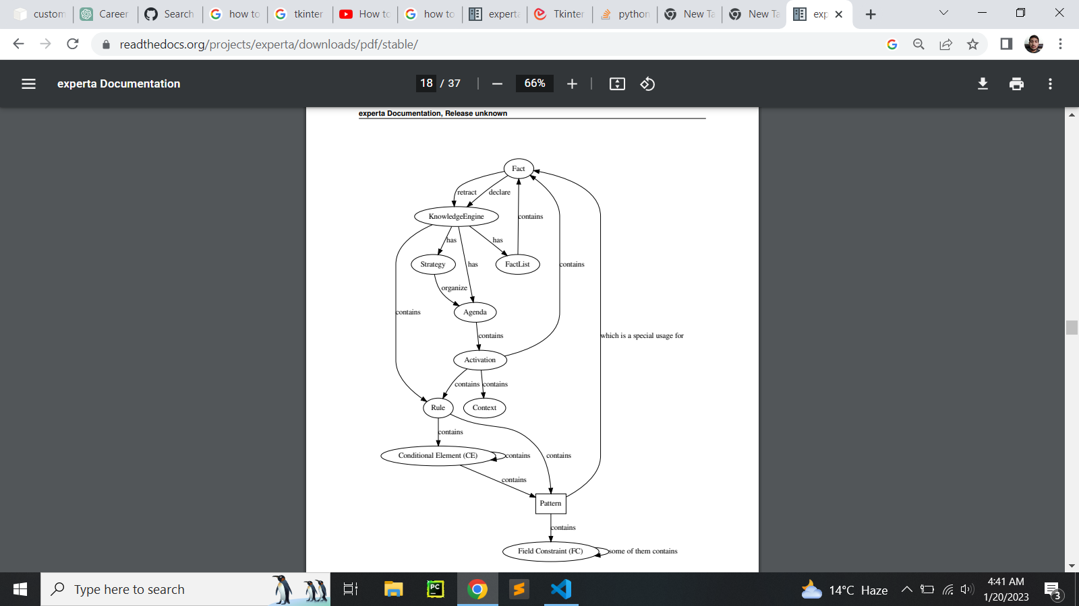

**Limitations of the project:**

* This project is trained on limited knowledge, so the results are not absolute and may have margin for errors
* This expert system only covers the field available in NED University as most of the data required to build knowledgebase was acquired from the universities website
* The expert system is modeled on merits of year 2021 and thus it may result in some disparity in the result

**Challenges Faced:**

* Data collection: Collecting accurate and up-to-date information about the different fields of study and career paths available to students can be a challenge, as job market trends and requirements change frequently.
* Rule creation: Creating a comprehensive set of rules that accurately evaluate the student's interests, skills, and aptitudes and match them with the most suitable fields of study and career paths can be challenging. The rule base needs to be updated regularly to reflect the latest job market trends.

**Future Expansions:**

There could be lot more improvements to be done the projects. And it could be expanded in many ways. Among which some could be

* The integration of machine learning algorithms could be used to improve the accuracy and efficiency of the system. Machine learning algorithms can be trained on a large dataset of student profiles to improve the system's ability to match students with the most suitable fields of study and career paths.
* A project lacks a proper user interface. Which could be implemented to give user a god experience
* Making the system cloud-based will enable the system to be accessed from anywhere and at any time.

**Screenshots:**

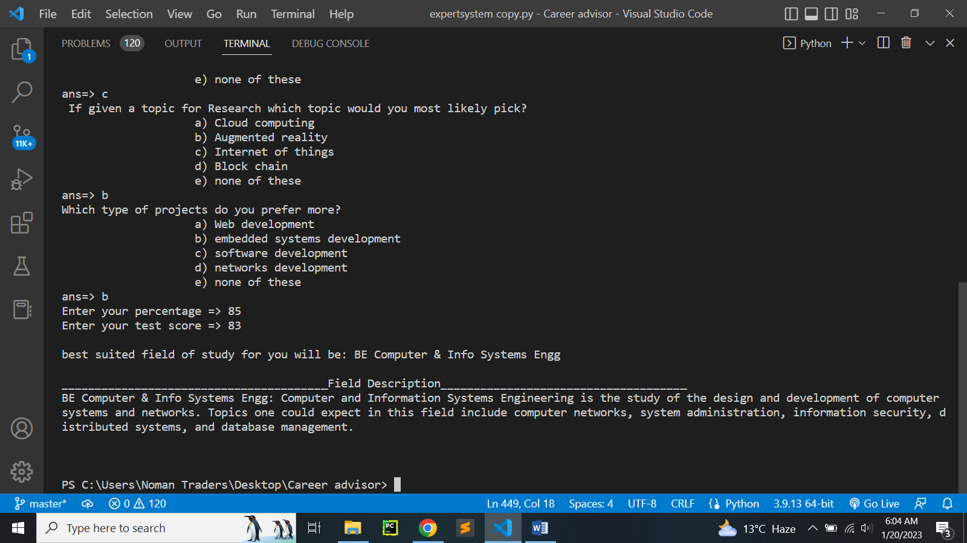

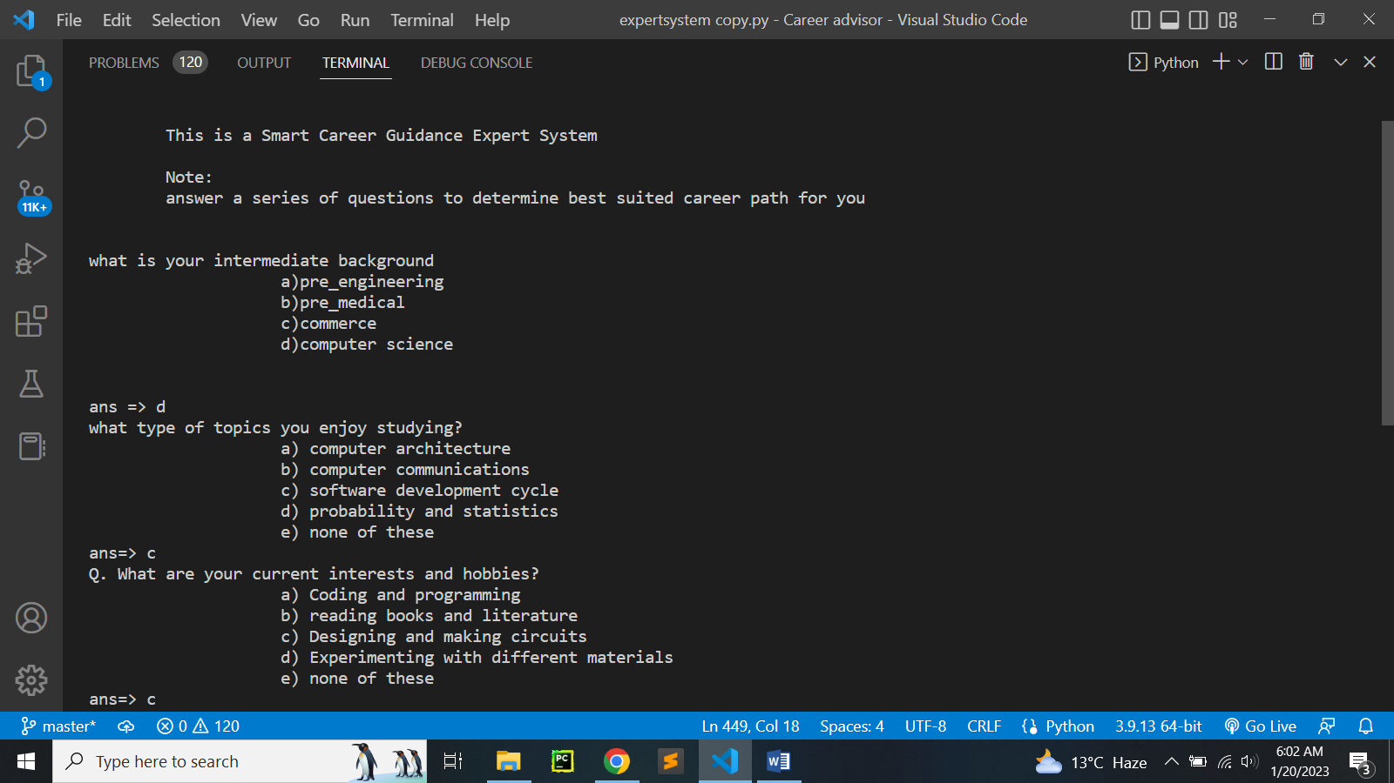

**Referenced sources:**

<https://www.neduet.edu.pk/sites/default/files/Admissions-2022/Prospectus_2022.pdf>

<https://www.ilmkidunya.com/>